Assignments on String

1. Using features of Java 11, read the data from a text file (**File name:** StudentList.txt). Calculate the count of students and print the names as well as the total count of students on the screen. (If any line in file doesn’t contain a name, for such a record blank space should not be printed in the output)

Hint: Use java 11 features of files and String methods to reduce the lines of code to be written.

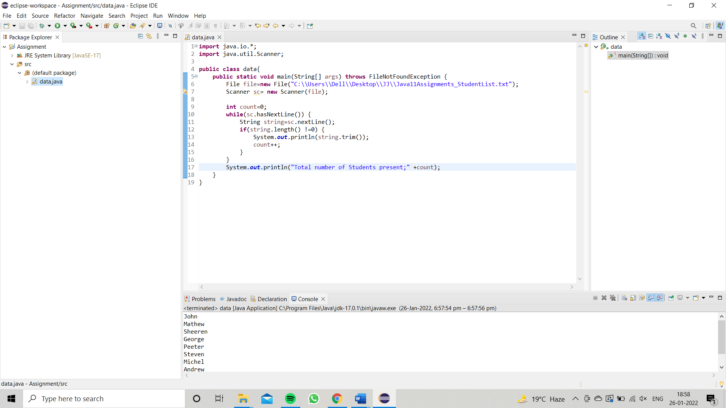

1. Write a program with menu to accept the price of certain items and display their total. When user selects Option 1: should accept the prices of different products and insert these prices into first file (each amount to be inserted in a newline in the file). Next, total of these values should be saved in a new file. Option 2: should allow the user to view the total of these prices from the second file.

**Sample Output**:

Select your option (**1**: Insert New Price, **2**: View Purchase Total, **3**: Exit)

> 1

* + Insert 1st price:

> 100

* + Price has been saved to the file
  + Do you want to enter price for more items? (Yes/No)
  + Yes
  + Insert 2nd price:
  + 200
  + Price has been saved to the file
  + Do you want to enter price for more items? (Yes/No)
  + No
  + Select your option (**1**: Insert New Price, **2**: View Purchase Total, **3**: Exit)
  + 2
  + Total Price of all items is: 300
  + Select your option (**1**: Insert New Price, **2**: View Purchase Total, **3**: Exit)
  + 3

Hint: Use java 11 features of files and String methods to reduce the line of code.

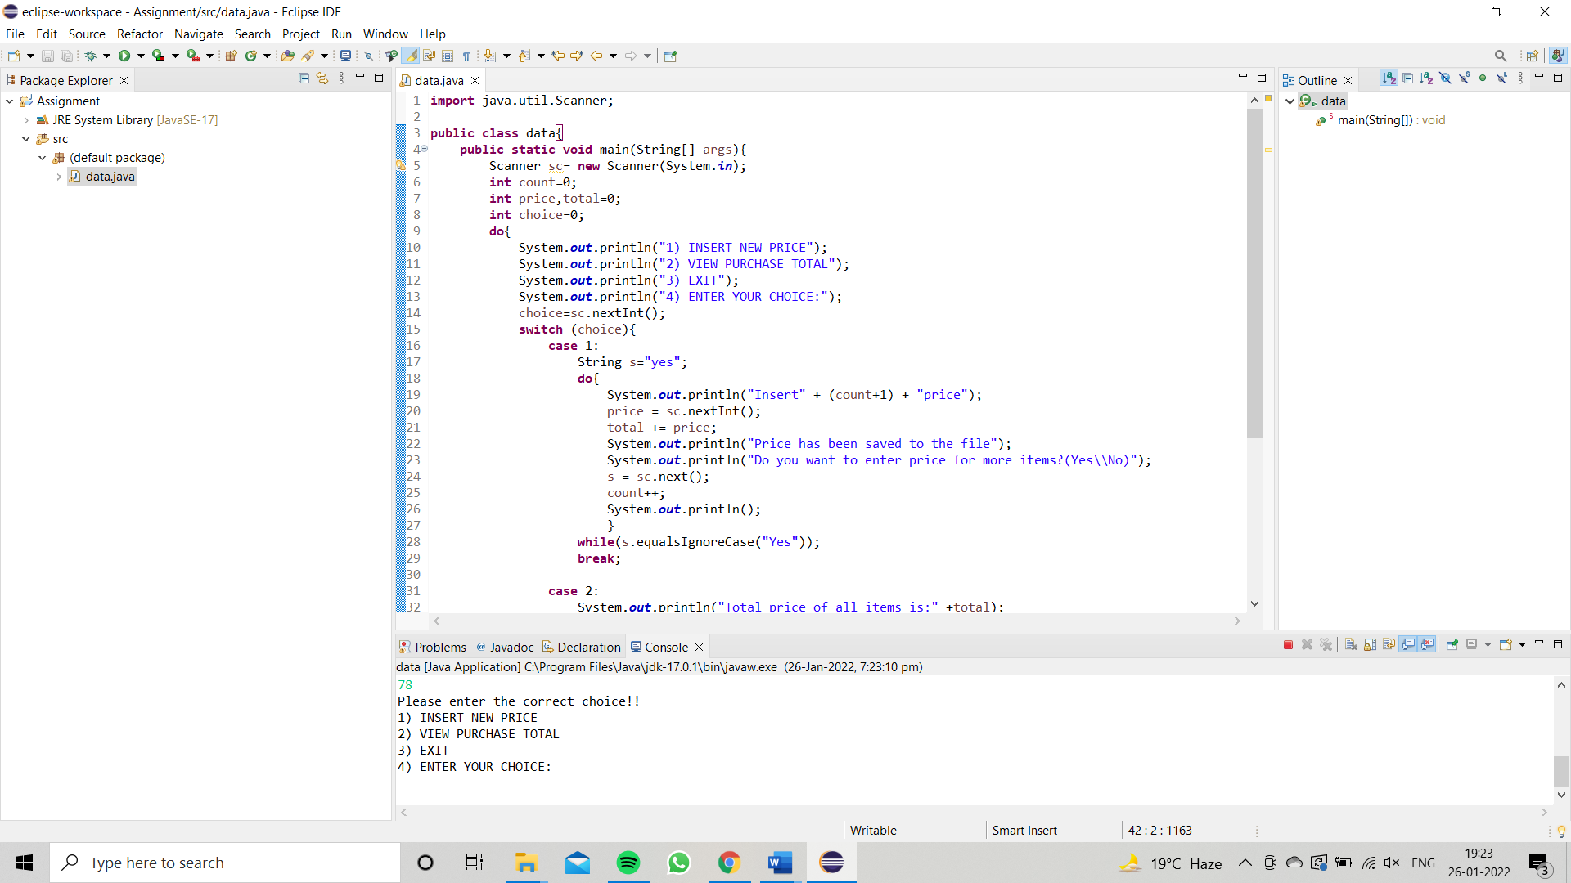

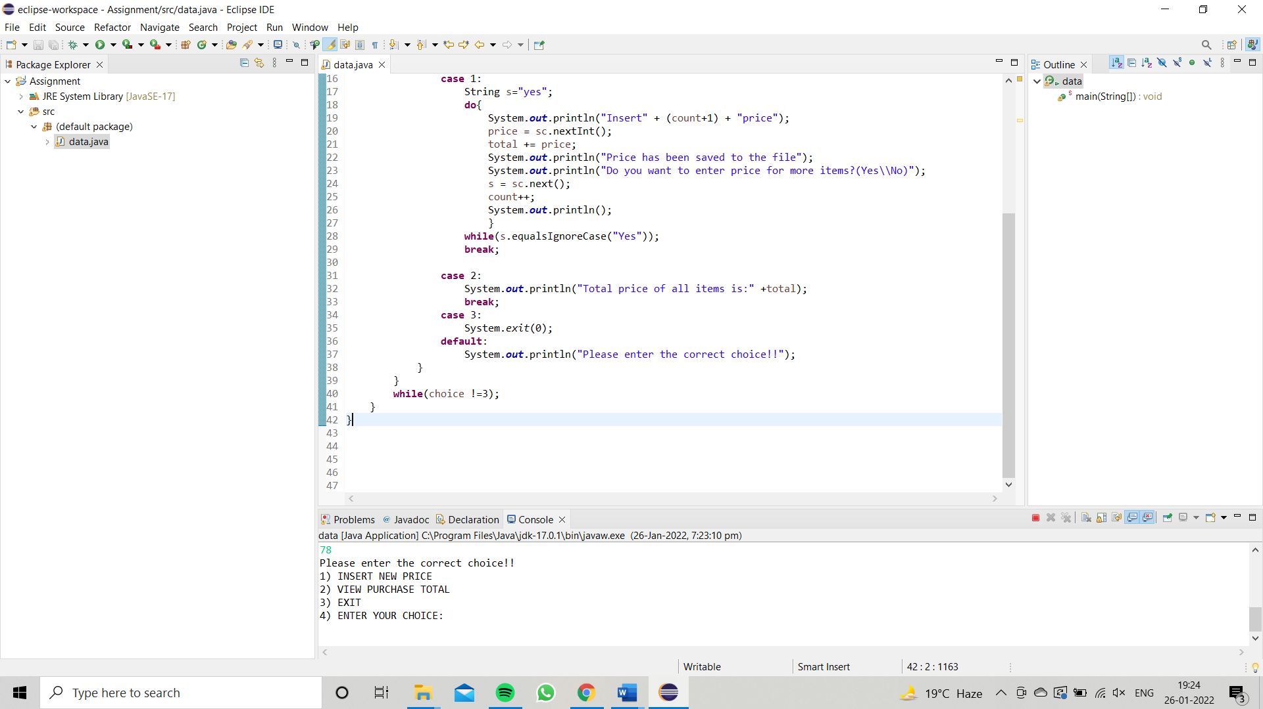

1. Write a code using HttpClient API which sends a GET request

to https://httpbin.org/get, and print out the response header, status code, and body for the given URL.

**Sample output** could be (Note: date and other attribute values may differ in your results):

access-control-allow-credentials:[true] access-control-allow-origin:[*] connection:[keep-alive]

content-length:[273]

content-type:[application/json] date:[Fri, 06 Aug 2021 13:07:41 GMT]

server:[gunicorn/19.9.0] 200

{

"args": {}, "headers": {

"Content-Length": "0",

"Host": "httpbin.org",

"User-Agent": "Java 11 HttpClient Bot",

"X-Amzn-Trace-Id": "Root=1-610d341d-092dc33f698b192a219426d1"

},

"origin": "43.255.221.184",

"url": "https://httpbin.org/get"

}

